**COURSE PROJECT REPORT**

**AY: 2021-22 Semester -I**

**Subject:** Digital Design

**Subject code:** ET3206

**Prepared by:**

|  |  |  |  |
| --- | --- | --- | --- |
| **Div.** | **Roll no:** | **GR No:** | **Name:** |
| B | 33 | 11910309 | Husain Baramatiwala |
| 37 | 11910511 | Dhruv Jain |
| 44 | 11910145 | Aditya Joshi |
| 42 | 11910158 | Yash Jog |
| 31 | 11910998 | Spandan Hiwarkhede |

**Project Title:** Car Parking System Password Verification Using Verilog

**Proposed system:**

* Description:

The project is to implement a car parking system in Verilog. In the entrance of the parking system, there is a sensor which is activated to detect a vehicle coming. Once the sensor is triggered, a password is requested to open the gate. If the entered password is correct, the gate would open to let the vehicle get in. Otherwise, the gate is still locked. If the current car is getting in the car park being detected by the exit sensor and another the car comes, the door will be locked and requires the coming car to enter passwords

* Advantages and Applications:

1. The car’s owner that has the password can only park their car in parking no one else can park.
2. If the current car is getting in the car park being detected by the exit sensor and another the car comes, the door will be locked and requires the coming car to enter passwords.
3. Security against theft is also increased because if he/she doesn’t know password can take car in or out.
4. This type of system can be used in Malls, Apartment parking slot, etc.

**Hardware Requirement:**

* ZC702 board,
* AC power adapter (12 VDC),
* USB Type-A to USB Mini-B cable (UART communication),
* Digilent cable (programming & debugging),
* Ethernet cable (Connect target to host machine),
* Ultrasonic distance sensor,
* Keypad

**Software Requirement:**

* Xilinx ISE 8.1i

**System diagram:**

GATE

S1

S2

S2S@

CAR 2

CAR 1

**Software implementation:**

* Flow chart:

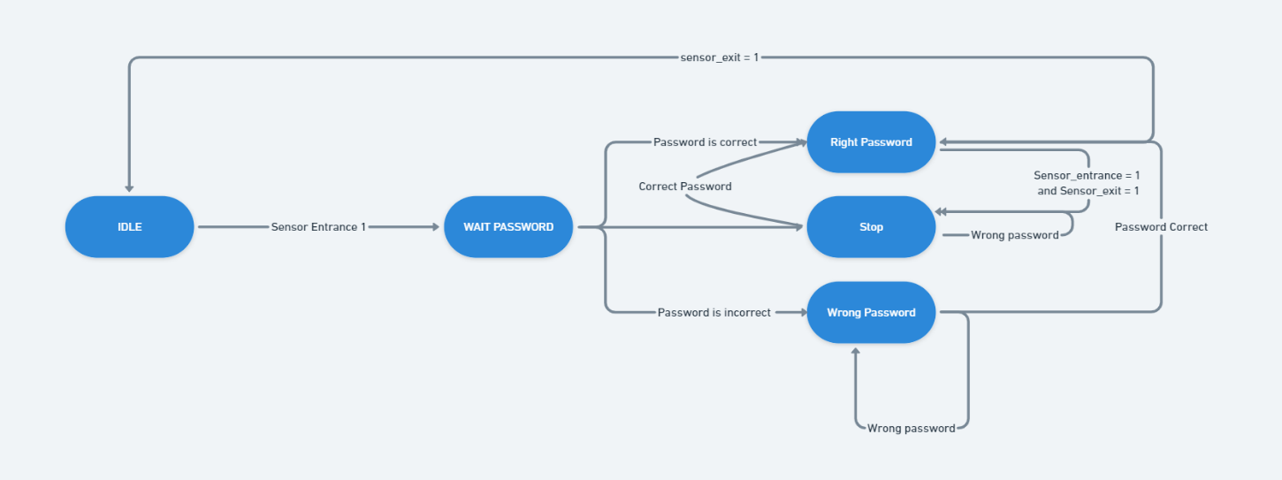

* Program with appropriate comment

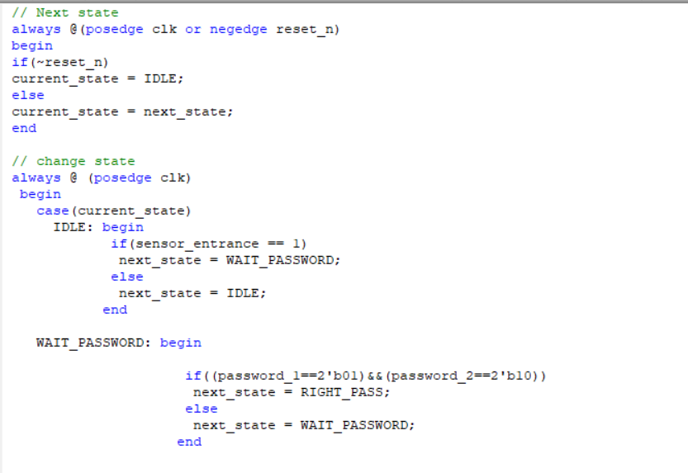

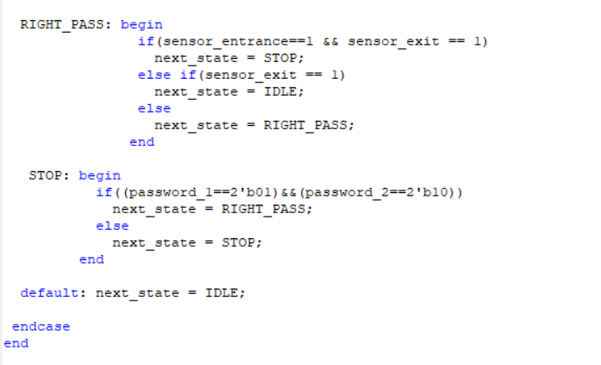

**B) Test Bench Main Code:**

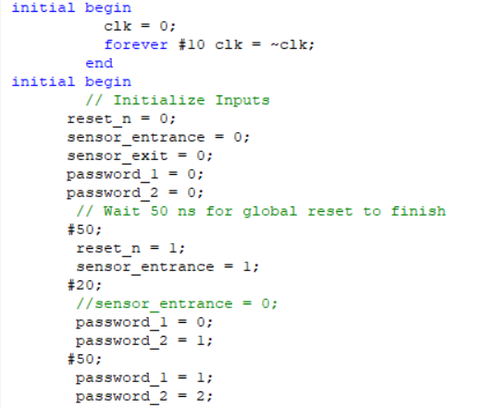

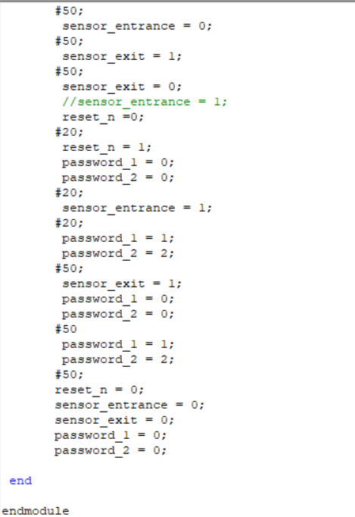

**Result:**

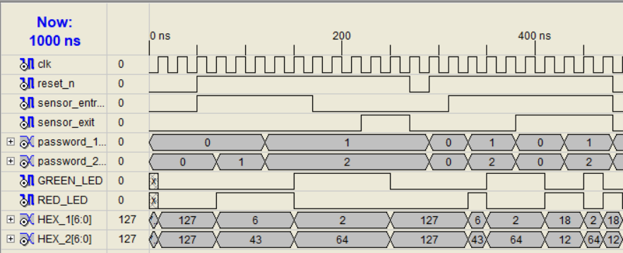

**Conclusion:**

* This project basically improves the security regarding car safety in car parking slot using password-based authentication system.
* This will also discard unwanted hiring of security guard for parking slot.
* Using the ZC702 board which include FPGA board can be configured using Xilinx software and some sensors that basically detect the incoming car the system can be implemented easily.